Directories Submission:
S.no | URL | 360schooltrips Screenshot
01 | http://wvchoops.com/submit.php | 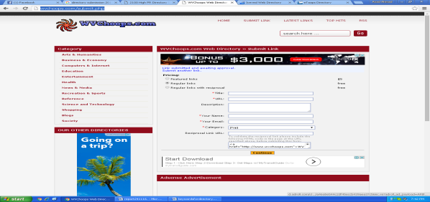
02 | http://iceved.com/submit.php?c=291&LINK_TYPE=2
03 | http://etaaps.org/submit?c=3483&LINK_TYPE=1 | 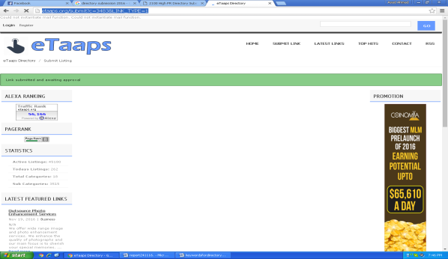
04 | http://edulogasp.com/submit.php?c=667&LINK_TYPE=2 | 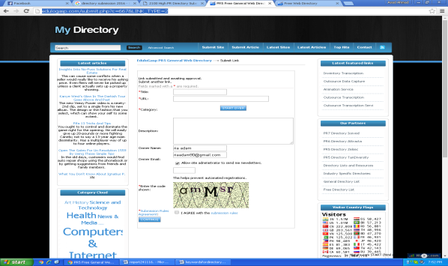
05 | http://trafficsimulator.net/submit?c=291&LINK_TYPE=1 | 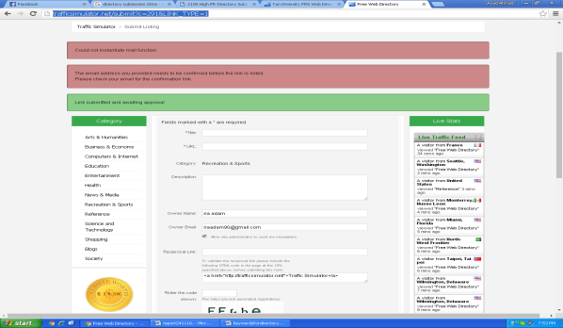
06 | http://tandiversity.com/submit.php?c=667&LINK_TYPE=2 | 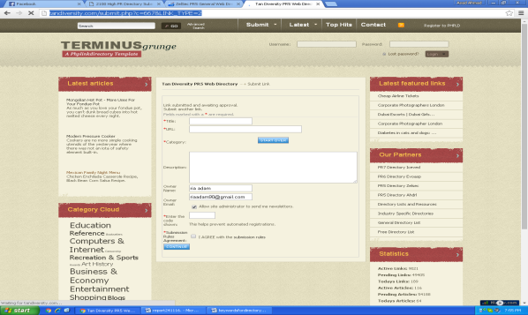
07 | http://zelsec.com/submit.php?c=667&LINK_TYPE=2 | 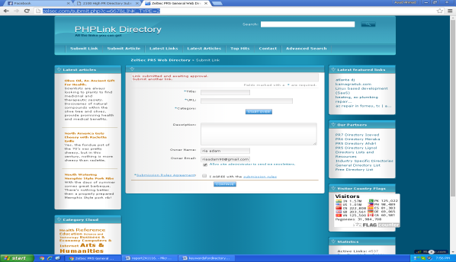
08 | http://defb.net/submit.php?c=667 | 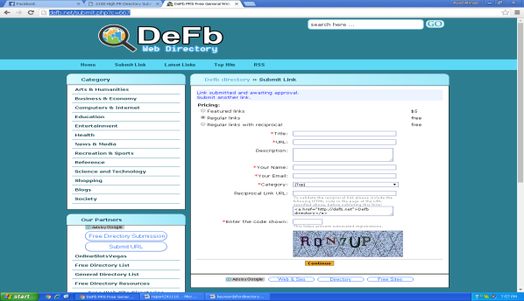
09 | http://eclyptix.com/submit.php?c=667 | 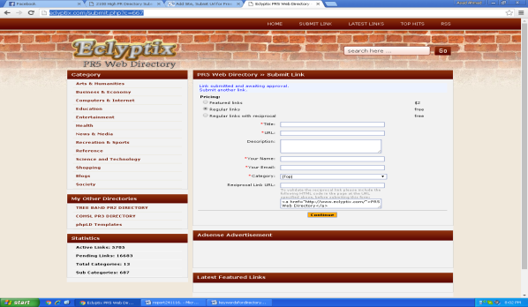
10 | http://www.umoz.org/submit.php | 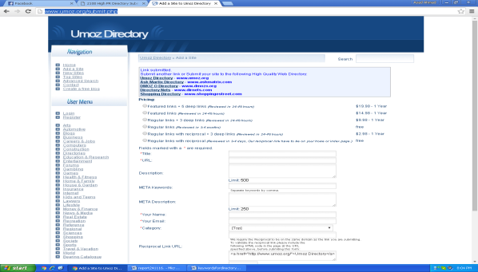
11 | http://llt8.com/submit.php?c=667 | 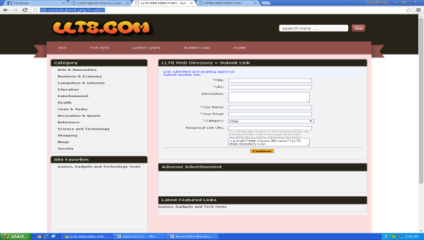
12 | http://pmin.org/submit.php?c=667 | 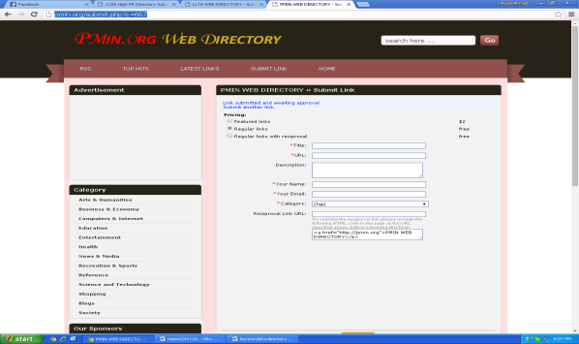
13 | http://concertstudy.net/submit.php?c=667&LINK_TYPE=2 | 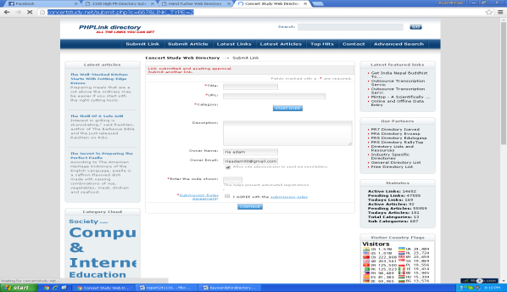
14 | http://handtucher.net/submit.php?c=667 | 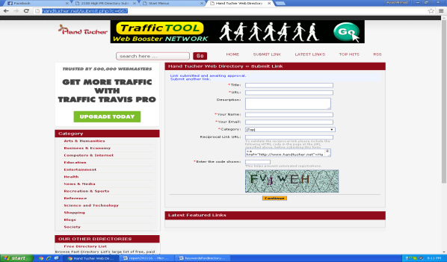
15 | http://startmenus.net/submit.php?c=667 | 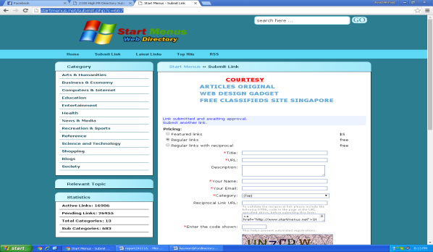
16 | http://hbnu.org/submit?c=667&LINK_TYPE=1 | 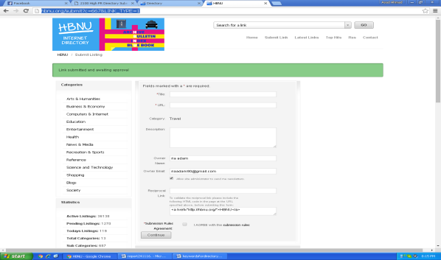
17 | http://conyerspayless.com/submit?c=667&LINK_TYPE=1 | 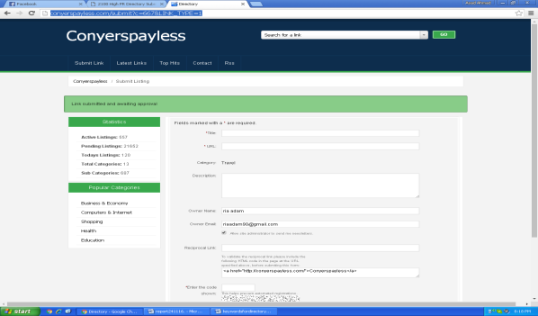
18 | http://qiaas.com/submit.php?c=667&LINK_TYPE=2 | 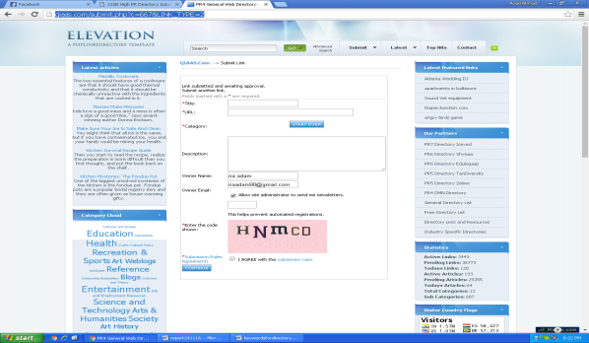
19 | http://diamondoa.org/submit.php?c=667 | 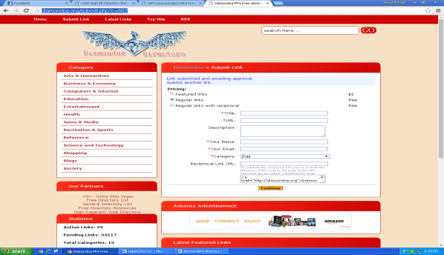
20 | http://omcommunication.net/submit.php?c=667 | 